**LECTURE 1: FLOWCHARTS**

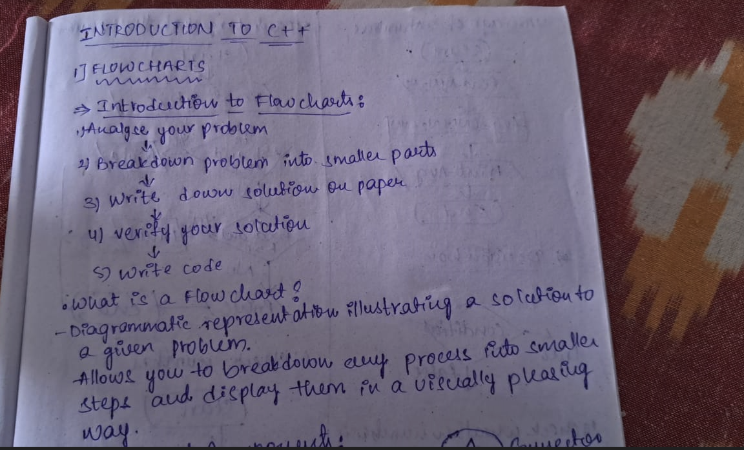

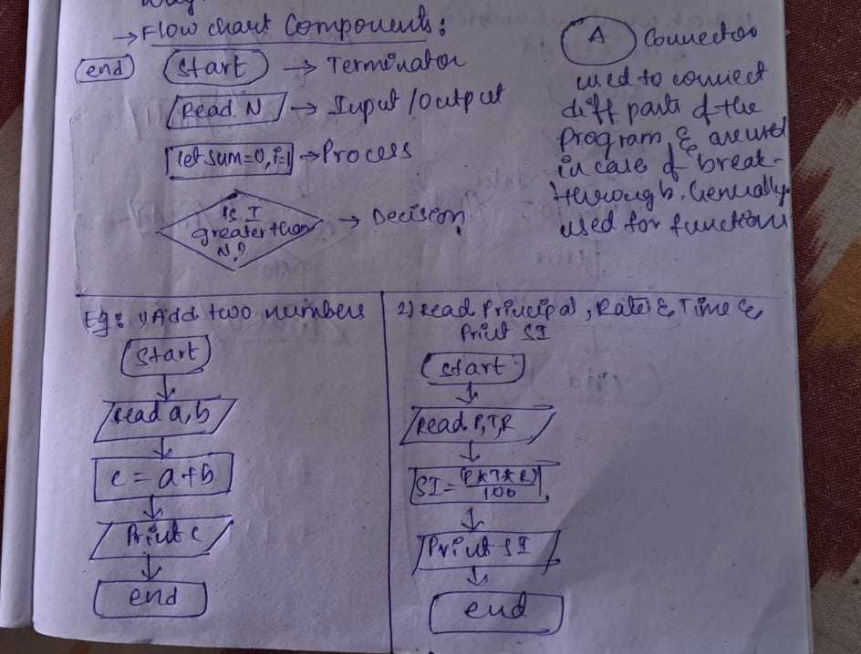

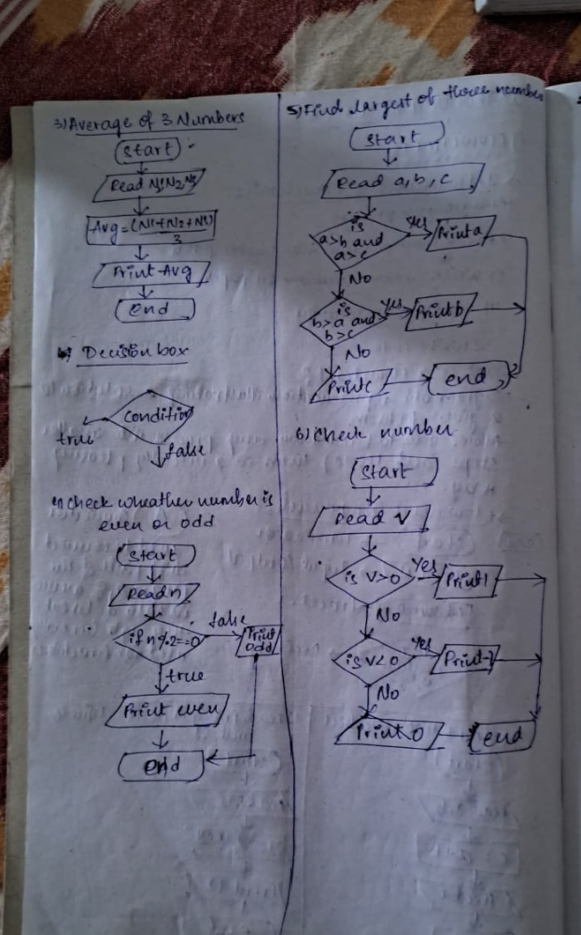

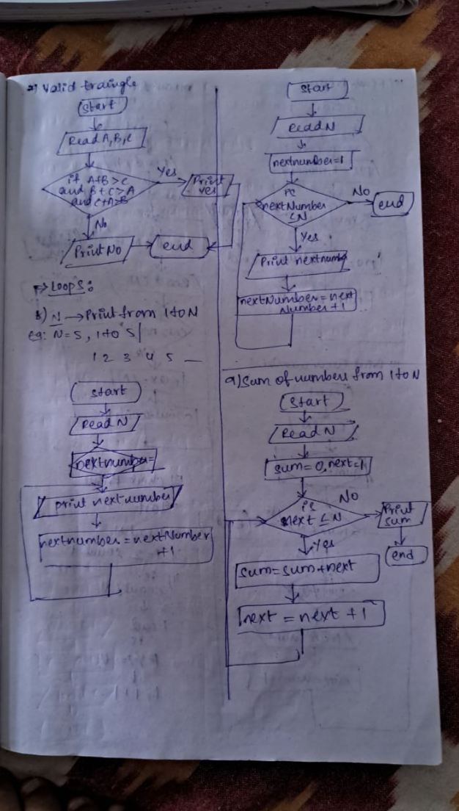

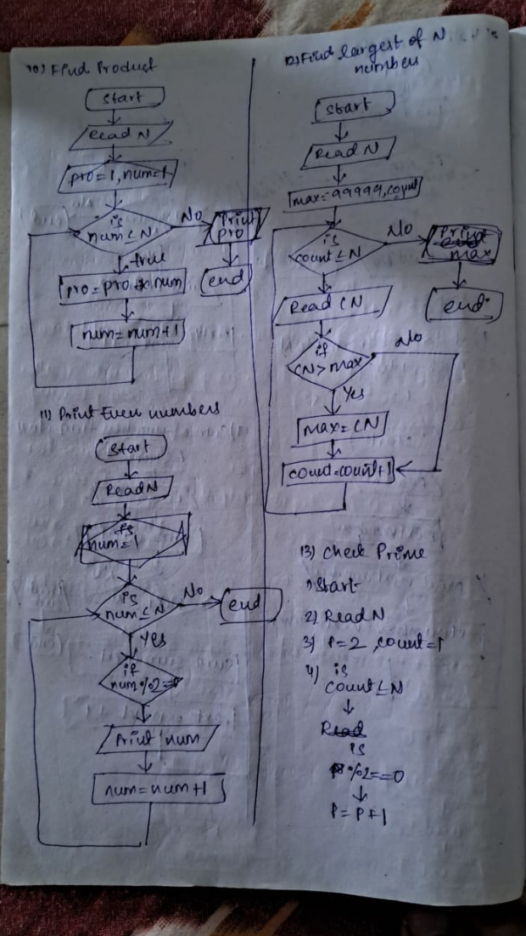

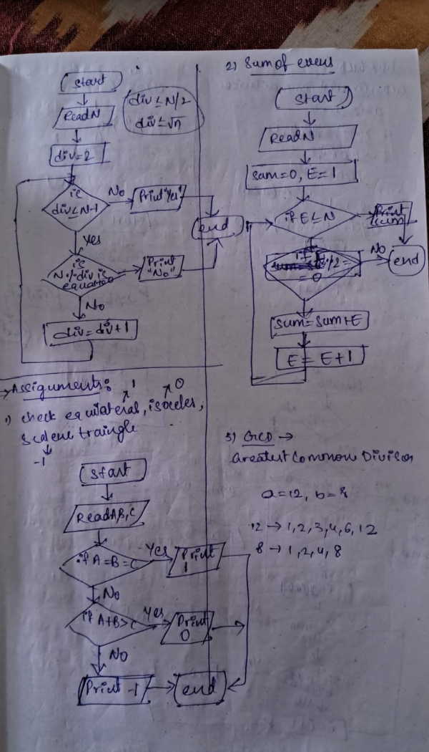

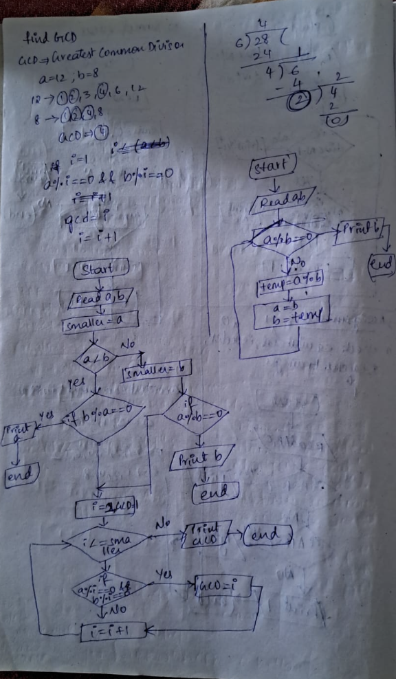

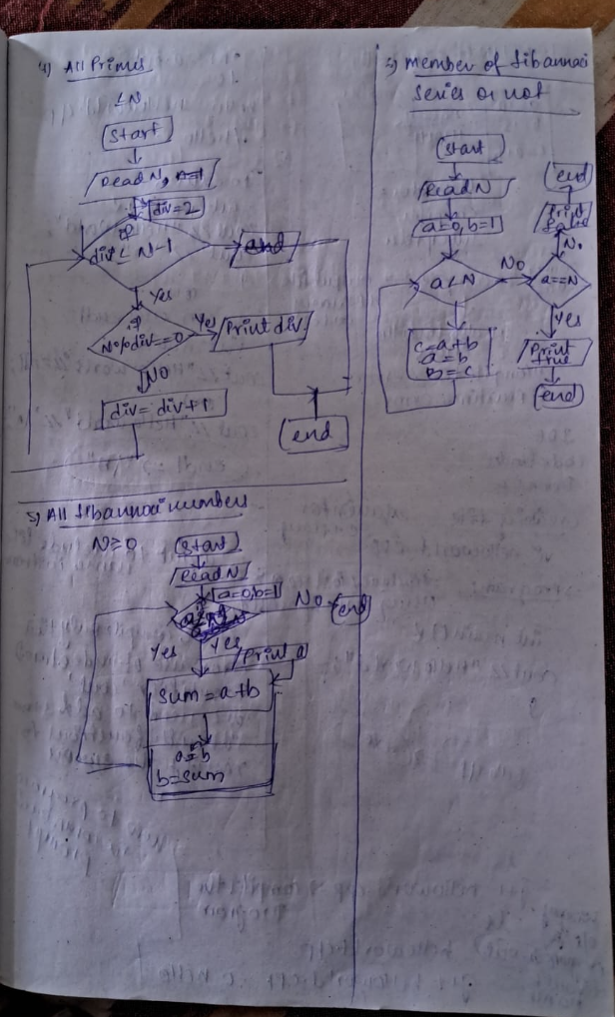

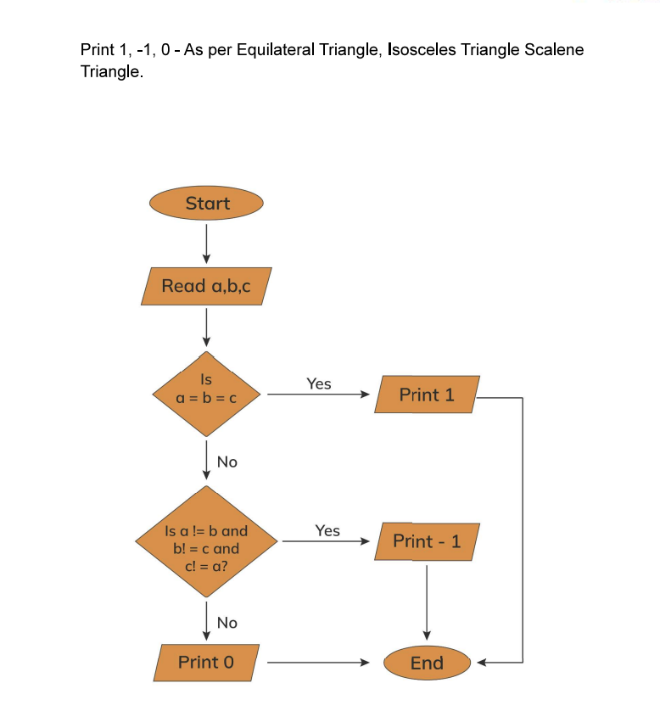

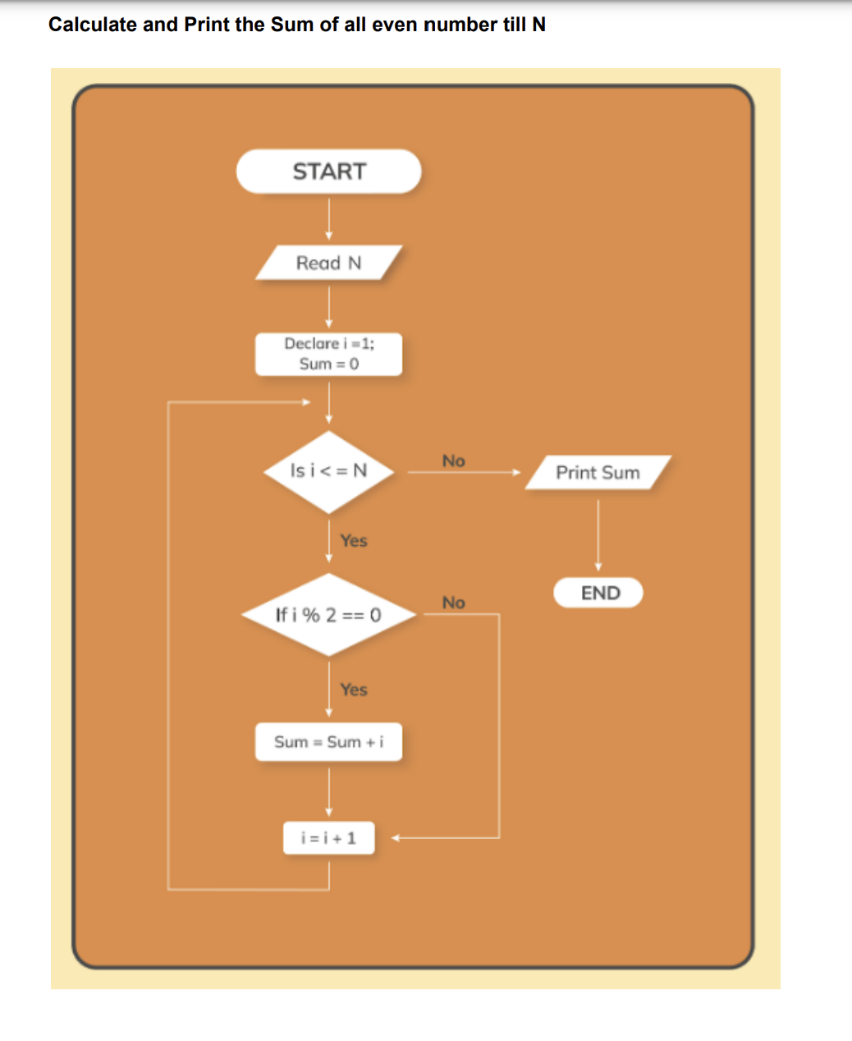

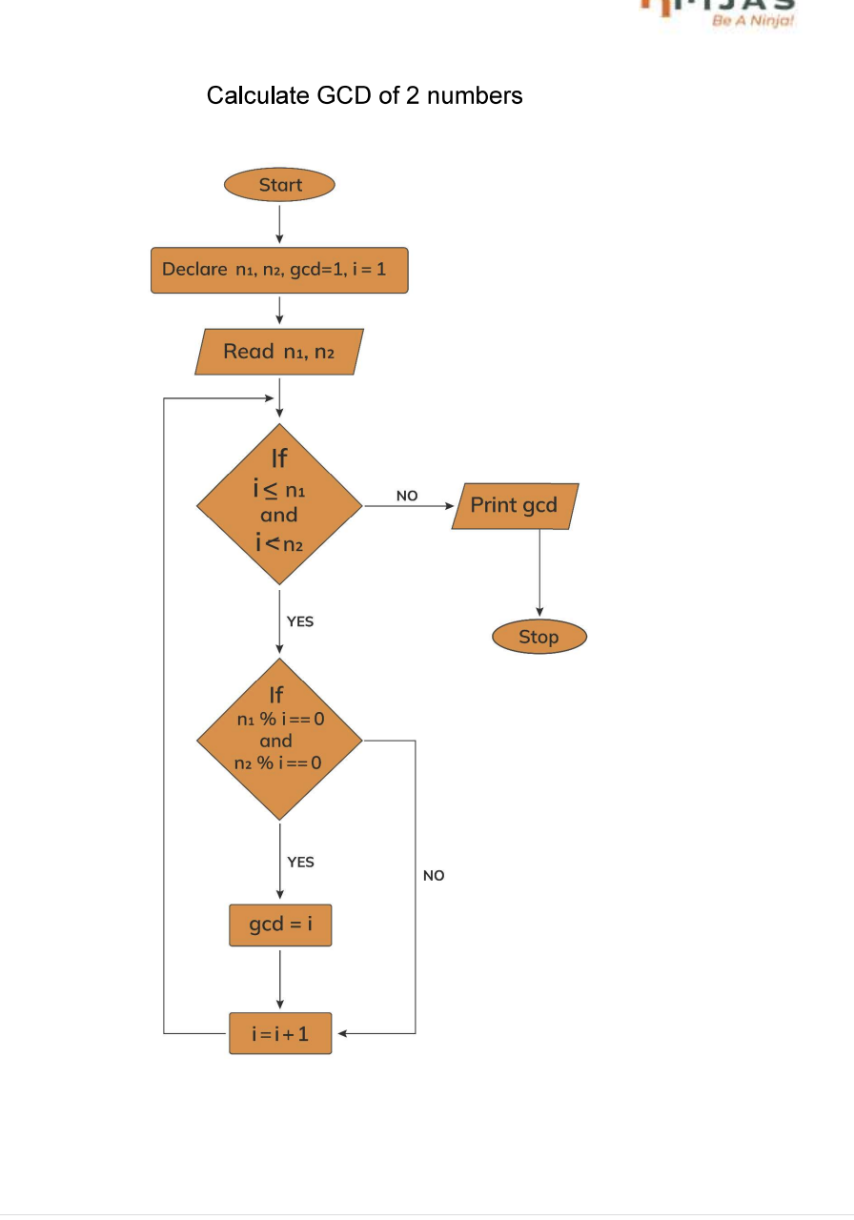

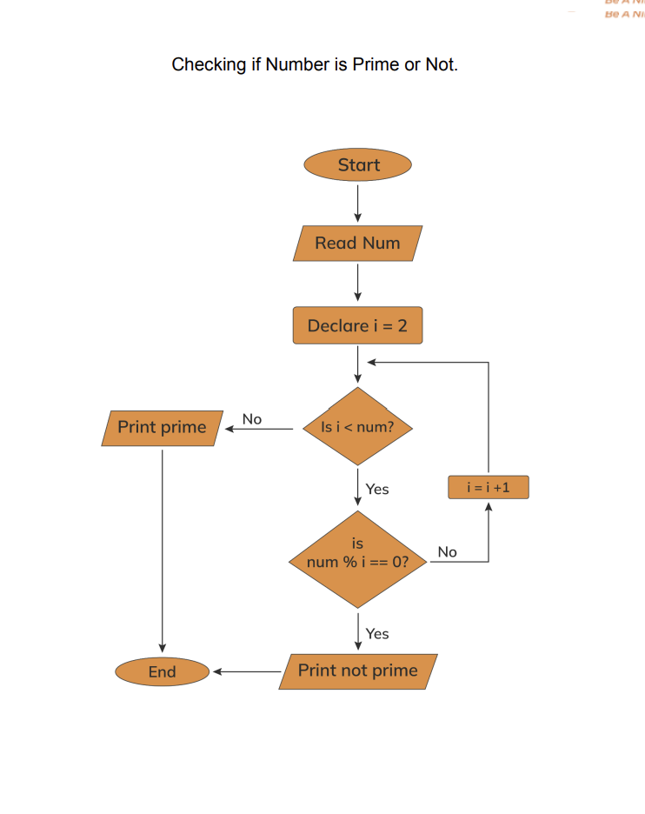

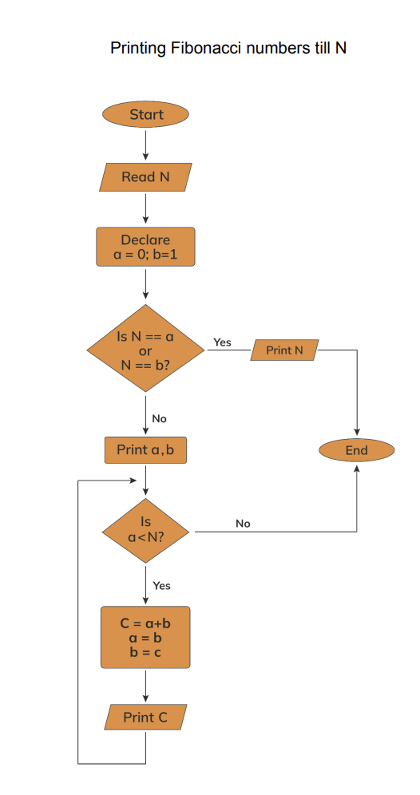

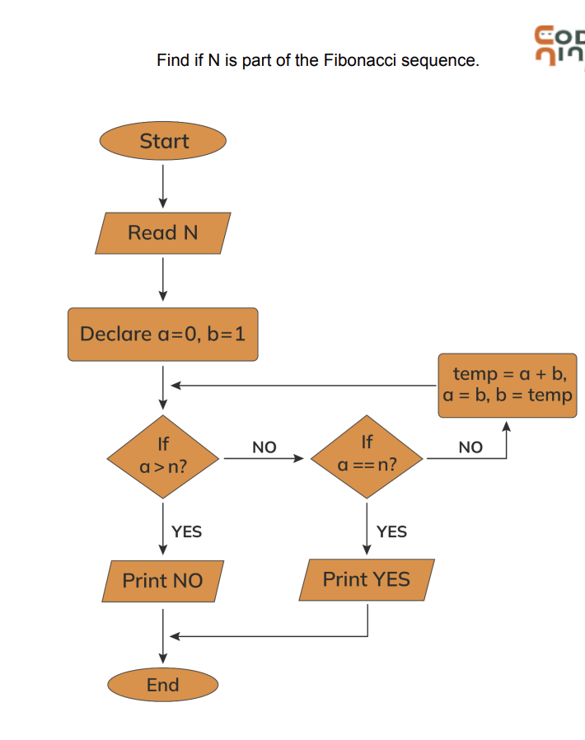

**Lecture 2 : Getting Started**

1.What will be the output of the following code ?

#include <iostream>

using namespace std;

int main(){

cout << code ;

}

**A:Error**

If we want to print something on screen exactly, we need to put that text in double quotes, otherwise error will come. For eg. cout << "code";

#### 2.What will be the output of the following code ?

#include <iostream>

using namespace std;

int main(){

cout << "career" << "labs";

}

A:careerlabs

The text will be printed exactly like we placed inside double quotes. So first we are printing "career". After printing, our cursor will be right next to the 'r' of "carrer". So "labs" will be printed right next to the "career" without any spaces between them.

**Datatype**

**1.**Which of the following data type stores longest decimal number ?

**A:double**

Out of all given options, only float and double can hold decimal numbers. Size of the float is 4 bytes and double is 8 bytes (in most of the compilers, as the size of data types is compiler specific). So double can store bigger decimal numbers.

#### 2.Compiler assigns a garbage value to an uninitialised local variable in C++ Programming ?

**A:True**

In C++, all variables contain garbage values before their initialisation.

#### 3.What will be the output of following statements -

bool a = true;

cout << a;

A:1

In c++, when we print the value of a bool variable, it prints either 0 (for false) or 1 (for true). It doesn't print "true" or "false".

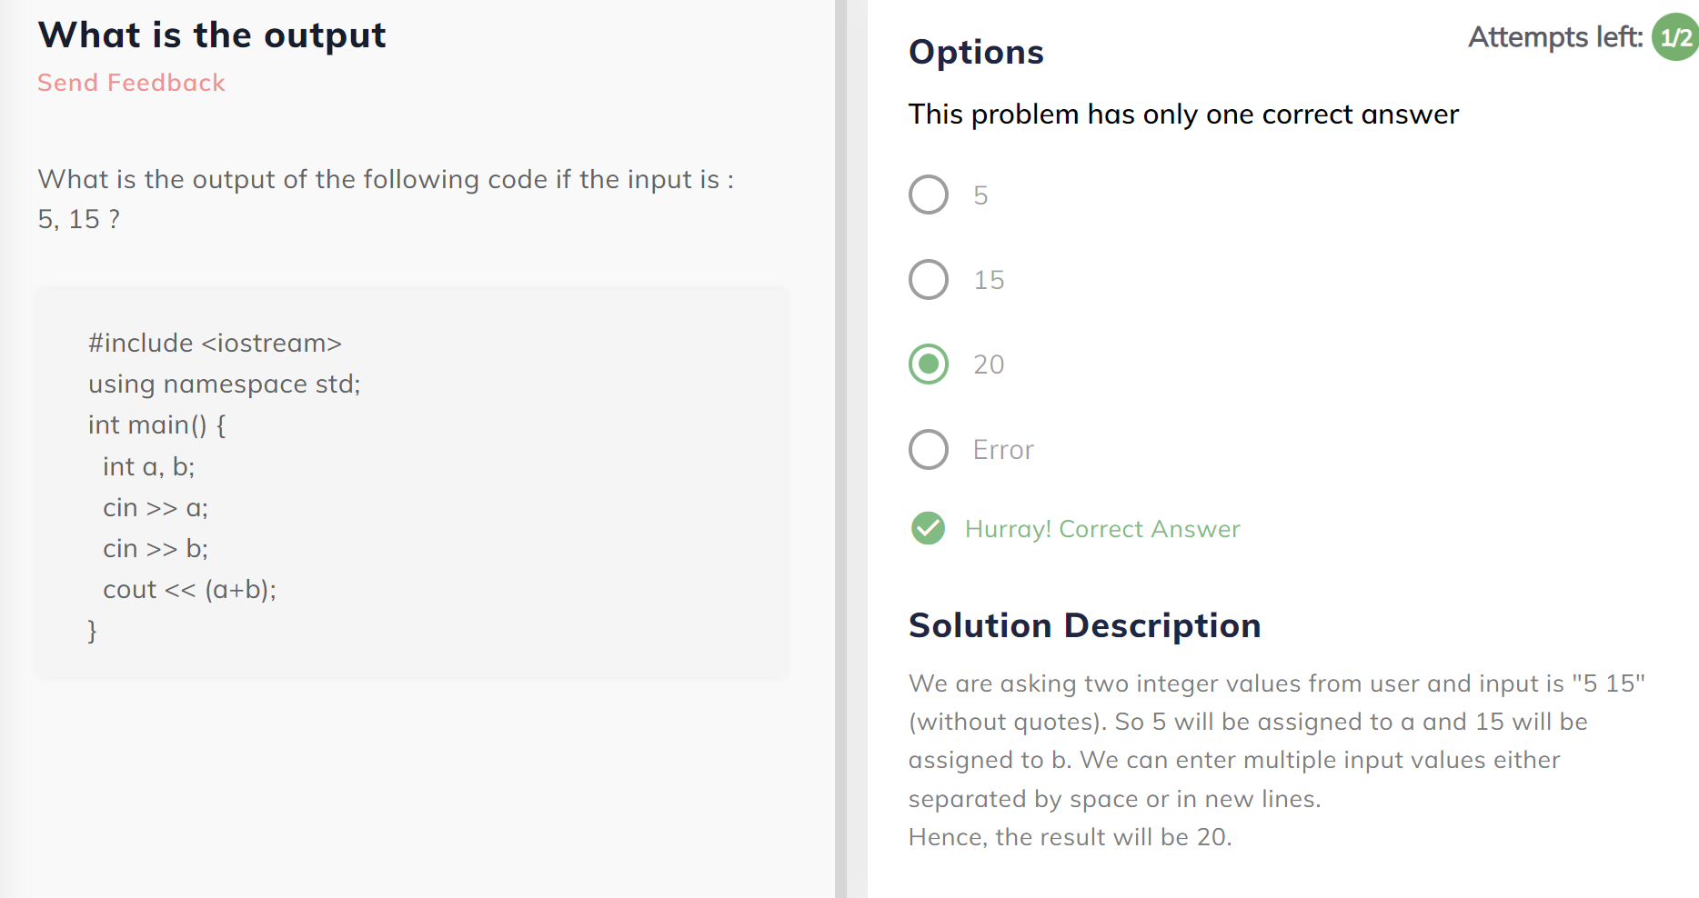

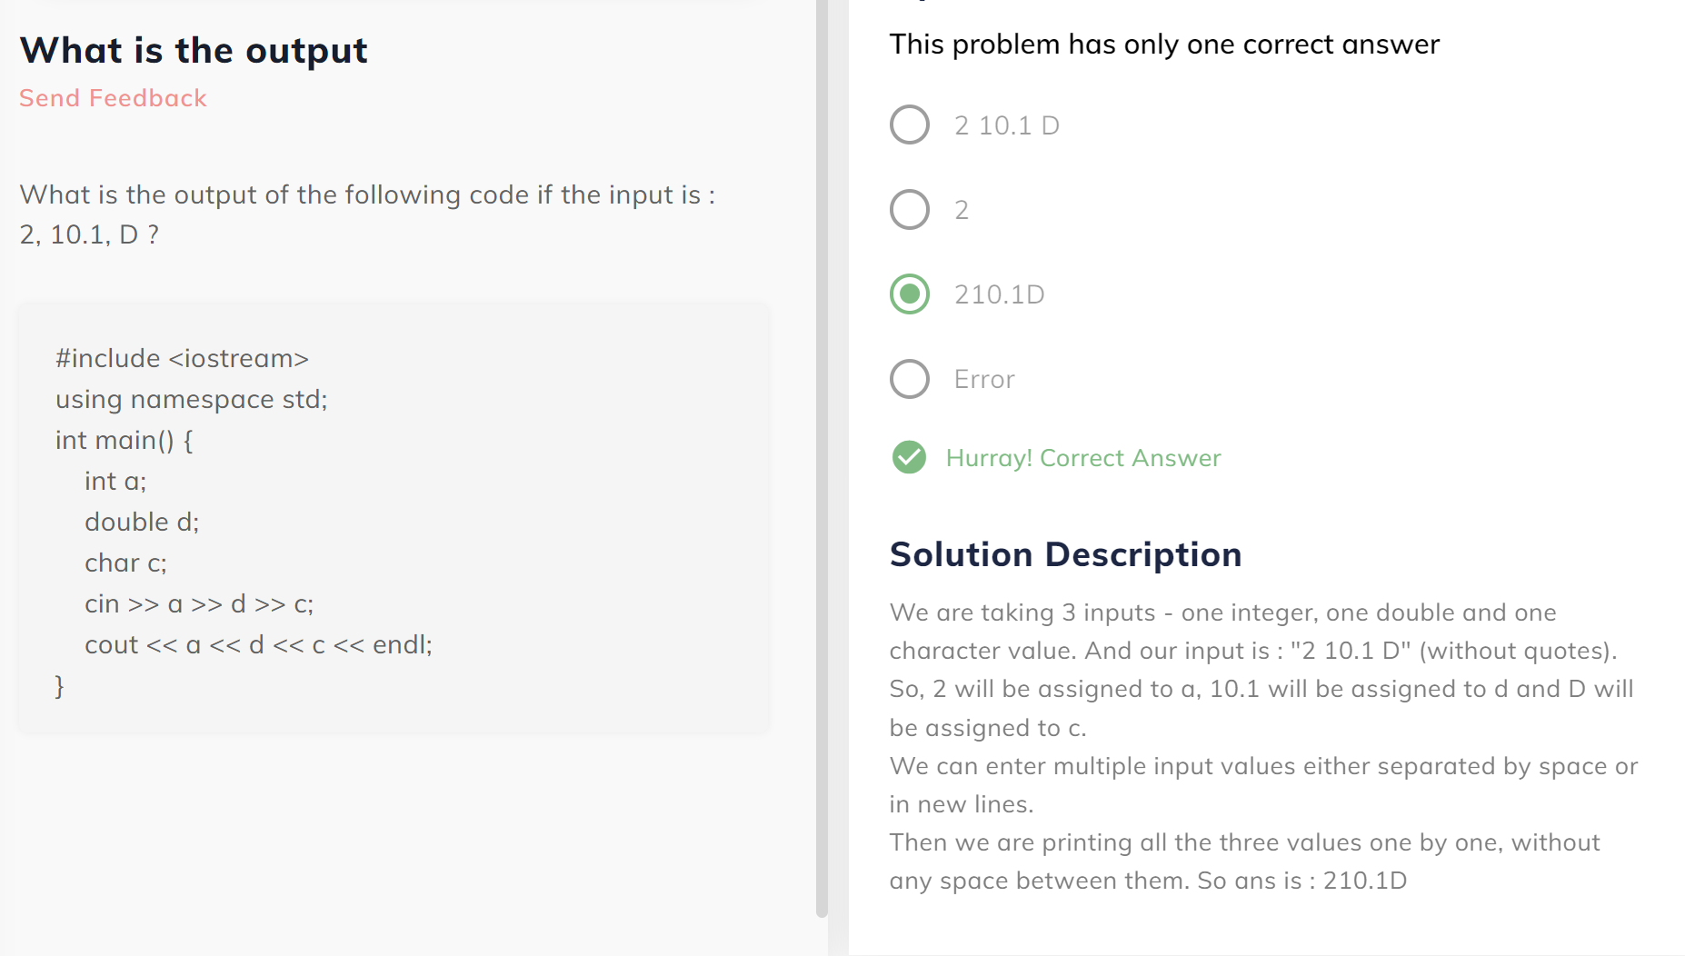

#### What will be the output ?

#include <iostream>

using namespace std;

int main()

{

double a = 6 / 4;

int b = 6 / 4;

double c = a + b;

cout << c;

}

A:2

When 6 / 4 is performed, both the operands of / are int hence answer will be an int i.e. 1. Hence the value of both a and b is 1. Thus a + b will be 2. In C++, if a double value doesn't contain any decimal value, only integer will be printed.

#include <iostream>

using namespace std;

int main()

{

double a = 55.5;

int b = 55;

a = a % 10;

b = b % 10;

cout << a << " " << b;

}

A:Syntax error

% can’t be used with double or float.

#include <iostream>

using namespace std;

int main()

{

int var1 = 5;

int var2 = 6;

cout << (var1 > var2);

}

A:0

'>' operator gives a boolean answer. And the condition is false. So answer will be false and 0 will be printed

(boolean variables print only 0 and 1).

Prime or not

#include <iostream>

using namespace std;

int main() {

int n;

cout << "Enter n" << endl;

cin >> n;

int d = 2;

bool divided = false;

while (d < n) {

if (n % d == 0) {

cout << "Not Prime" << endl;

divided = true;

}

d = d + 1;

}

if (!divided) {

cout << "Prime" << endl;

}

}

Lecture 3: Conditionals and Loops

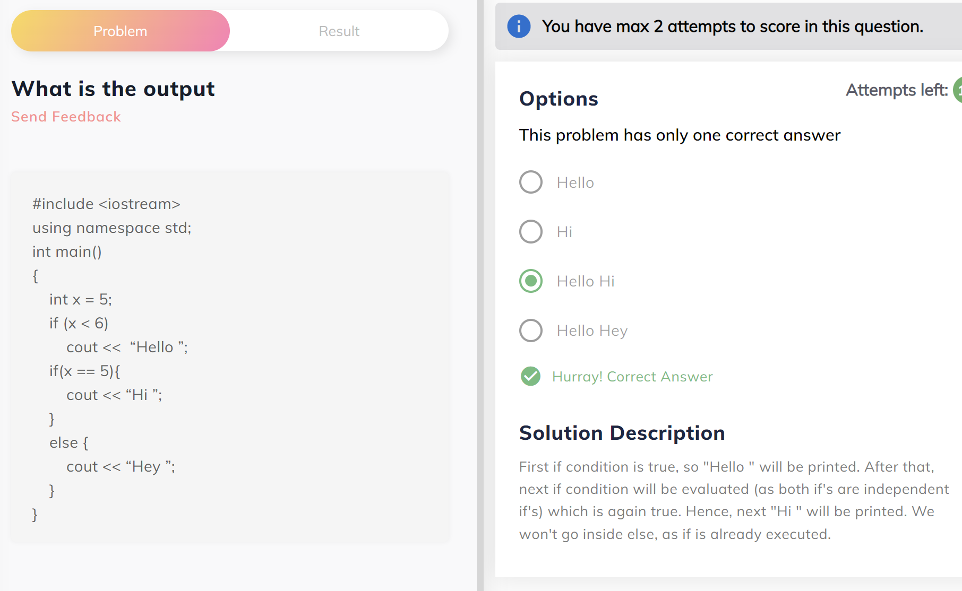

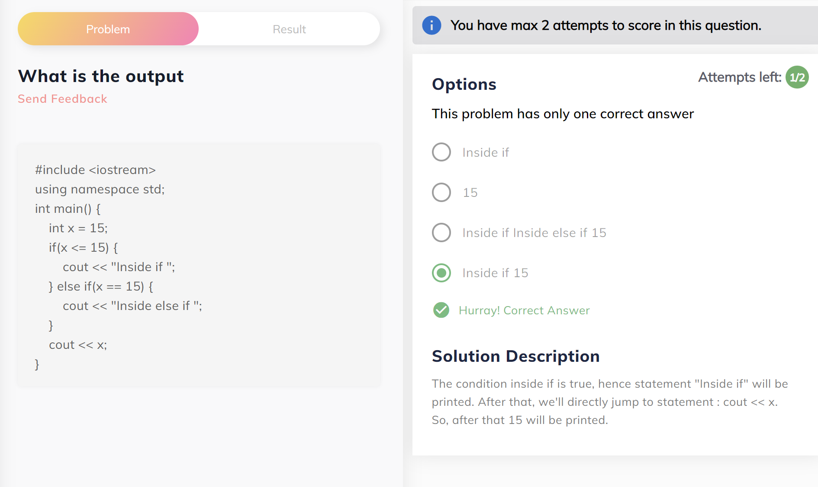

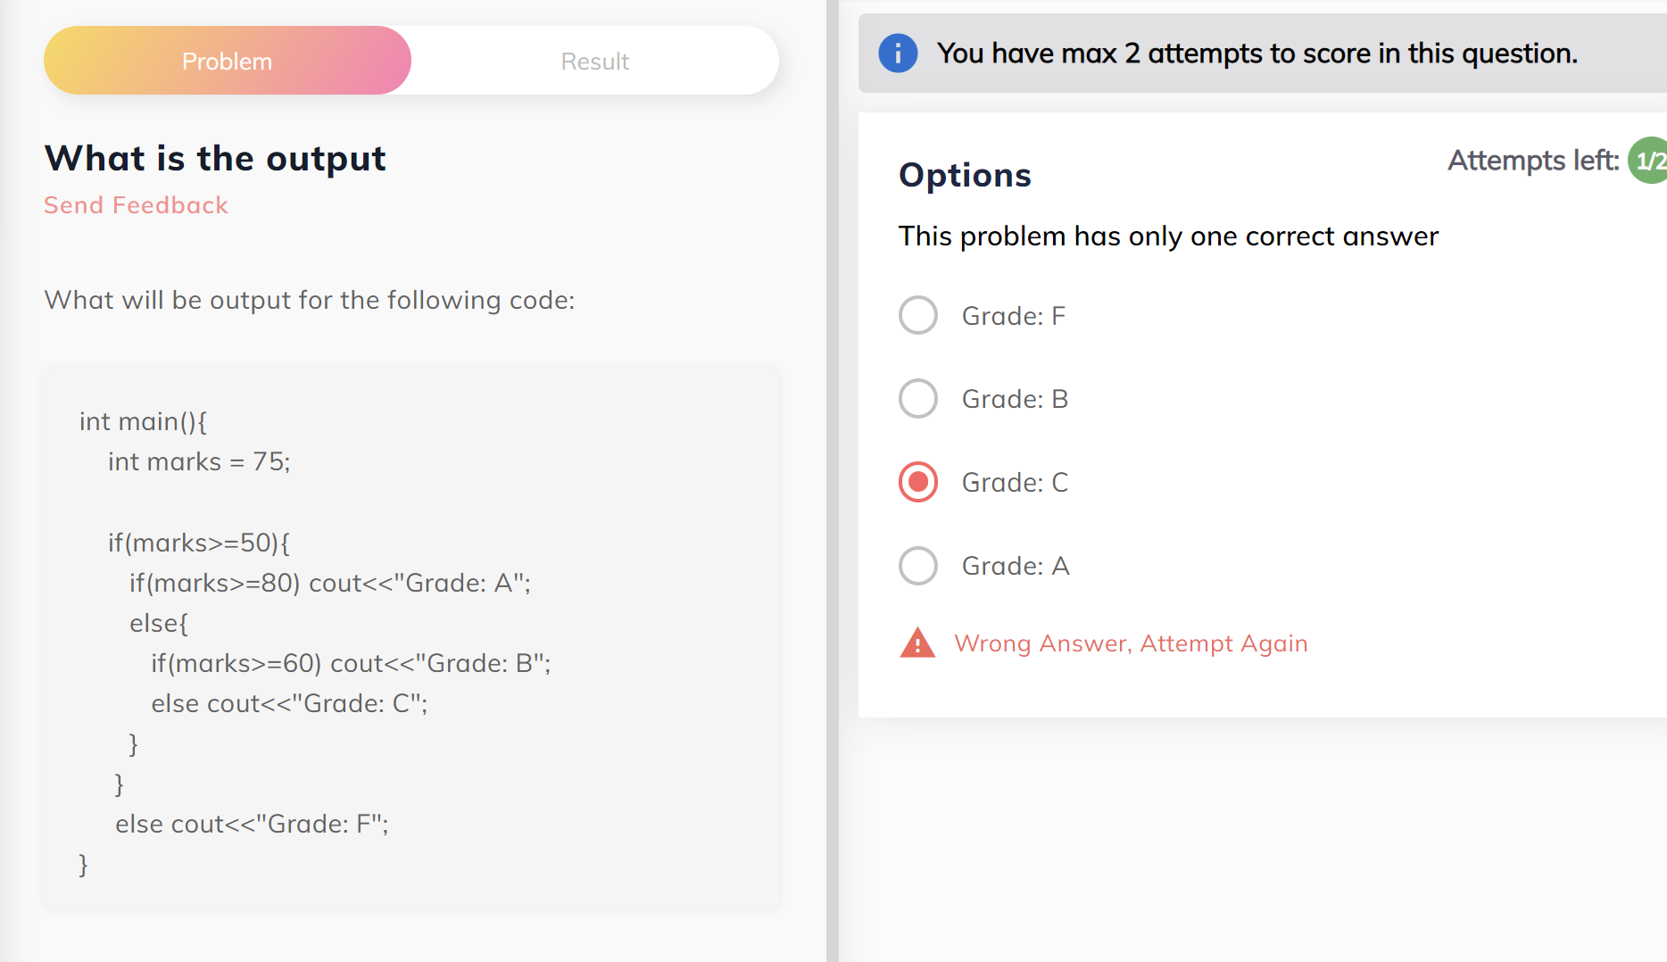

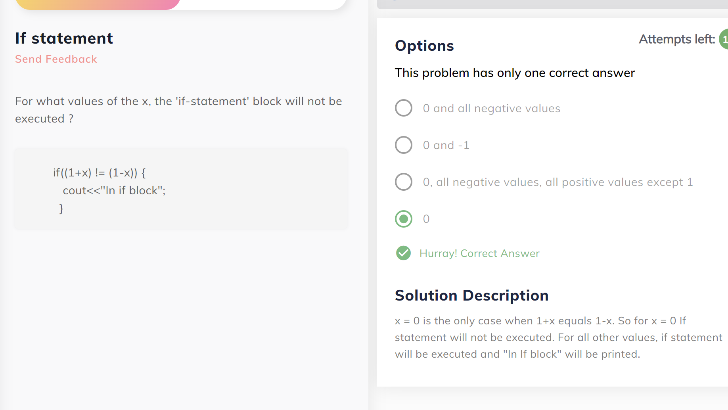

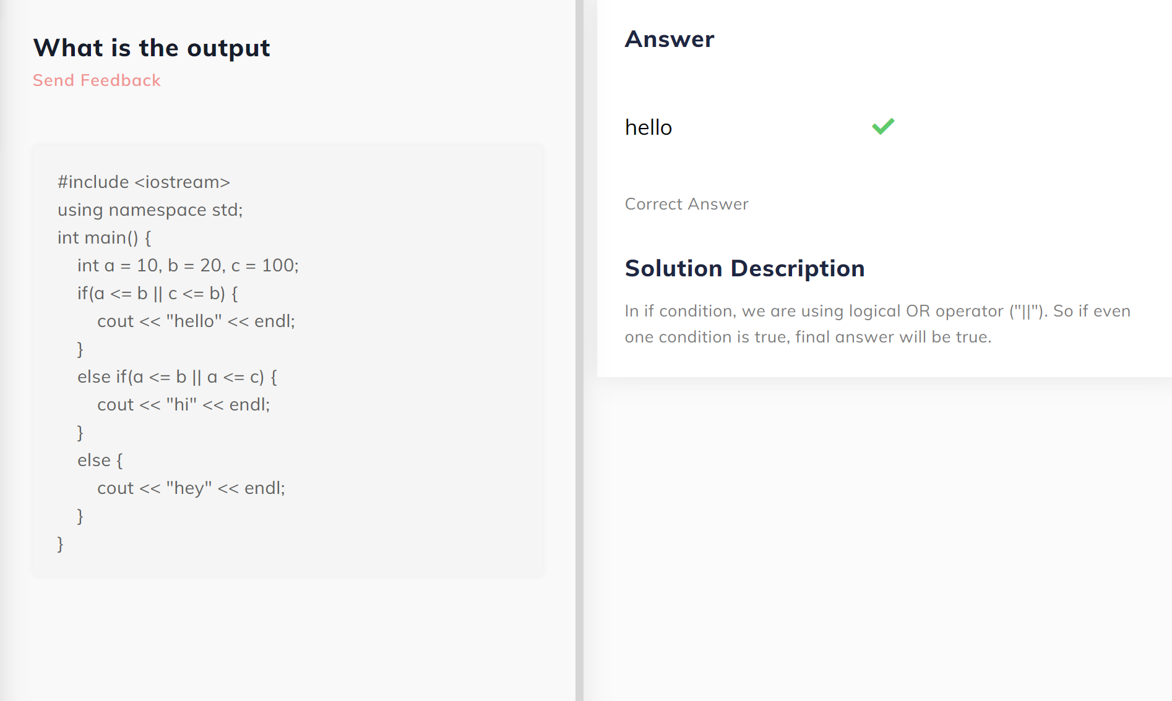

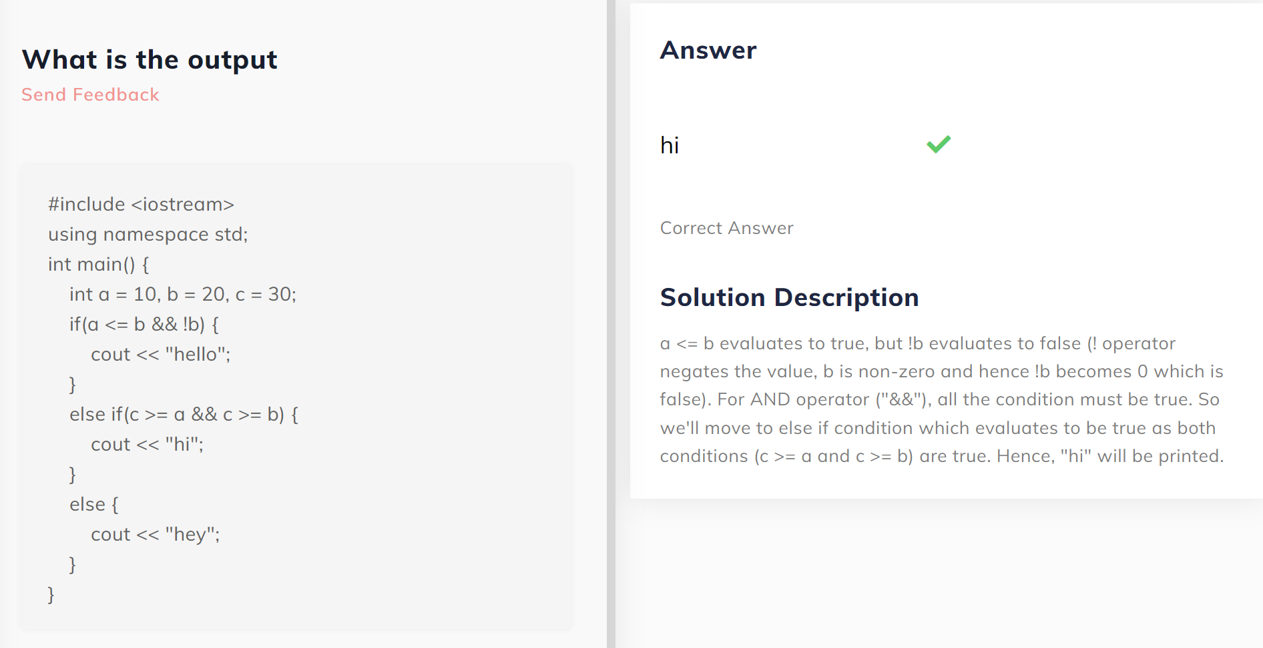

**Sum of Even Numbers till N**

#include<iostream>

using namespace std;

int main(){

    int n;

    int i=0;

    int sum=0;

    cin>>n;

    while(i<=n)

    {

        if(i%2==0)

       {

            sum=sum+i;

        }

        i=i+1;

    }

    cout<<sum;

    return 0;

}

**Check Case**

#include<iostream>

using namespace std;

int main()

{

    // Write your code here

    char c;

    cin >>c;

    if(c>=65 && c<=90)

    {

        cout<<"1";

    }

    else if(c>=97 && c<=122)

    {

        cout<<"0";

    }

    else

    {

       cout<<"-1";

    }

}

**Fahrenheit to Celsius Table**

#include<iostream>

using namespace std;

int main()

{

    int s,e,w,c;

    cin>>s>>e>>w;

    while(s<=e)

    {

        c=((5.0)/9)*(s-32);

       cout<<s<<" ";

        cout<<c<<endl;

        s=s+w;

    }

}

PATTERNS

1. #include <iostream>

using namespace std;

int main() {

    int n;

    cout << "Enter n"  << endl;

    cin >> n;

    int i = 1;

    while (i <= n) {

        int j = 1;

        while (j <= i) {

            cout << j;

            j = j + 1;

        }

        cout << endl;

        i = i + 1;

    }

}

#include <iostream>

using namespace std;

int main() {

    int n;

    cout << "Enter n"  << endl;

    cin >> n;

    int i = 1;

    int val = 1;

    while (i <= n) {

        int j = 1;

        while (j <= i) {

            cout << val;

            j = j + 1;

            val = val + 1;

        }

        cout << endl;

        i = i + 1;

    }

}

#include <iostream>

using namespace std;

int main() {

    int n;

    cout << "Enter n"  << endl;

    cin >> n;

    int i = 1;

    int val = 1;

    while (i <= n) {

        int k = 1;

        while (k <= n - i) {

            cout << " ";

            k = k + 1;

        }

        int j = 1;

        while (j <= i) {

            cout << val;

            j = j + 1;

            val = val + 1;

        }

        cout << endl;

        i = i + 1;

    }

}

**Number Pattern 1**

#### Pattern for N = 4

1

23

345

4567

#include<iostream>

using namespace std;

int main(){

int n;

    cin>>n;

    int i;

    i=1;

    while(i<=n)

    {

        int j=1;

        int val=i;

        while(j<=i)

        {

            cout<<val;

        val++;

        j++;

    }

        cout<<endl;

        i++;

    }

}

**Number Pattern 2**

#### Print the following pattern

#### Pattern for N = 4

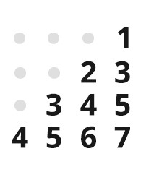

#include<iostream>

using namespace std;

int main(){

int n;

cin>>n;

int i=1;

while(i<=n)

{

    int k=1;

    while(k<=n-i)

    {

        cout<<" ";

        k++;

    }

    int j=1;

    int val=i;

    while(j<=i)

    {

       cout<<val;

       val++;

        j++;

    }

    cout<<endl;

    i++;

}

}

**Star Pattern**

Print the following pattern

Pattern for N = 4

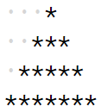

The dots represent spaces.

#include<iostream>

using namespace std;

int main(){

    int n;

    cin>>n;

    int i=1;

    while(i<=n){

        int j=1;

        while(j<=n-i){

            cout<<' ';

            j++;

        }

        int k=1;

        while(k<=2*i-1){

            cout<<"*";

            k++;

        }

        cout<<endl;

        i++;

    }

}

**Total Salary**

#### Write a program to calculate the total salary of a person. The user has to enter the basic salary (an integer) and the grade (an uppercase character), and depending upon which the total salary is calculated as -

totalSalary = basic + hra + da + allow – pf

##### where :

hra = 20% of basic

da = 50% of basic

allow = 1700 if grade = ‘A’

allow = 1500 if grade = ‘B’

allow = 1300 if grade = ‘C' or any other character

pf = 11% of basic.

#include<iostream>

#include <cmath>    //added this library for round() function

using namespace std;

int main() {

    //int bs,ts,a;

    int bs, a;      //

    double hra,da,pf;

    char allow;

    cin>>bs>> allow;

    hra=(0.2)*bs;

    da=(0.5)*bs;

    // pf=(0.3)*bs;

    pf=(0.11)*bs;   // pf = 11% of basic.

    if(allow=='A')

    {

        a=1700;

    }

    else if (allow=='B')

    {

        a=1500;

    }

    else

    {

        a=1300;

    }

    double ts=(bs+hra+da+a)-pf;

    //cout<<ts;

    int res = round(ts);    // Round off the total salary and then print the integral part only.

    cout<<res;              //

}

**Sum of even & odd**

#### Write a program to input an integer N and print the sum of all its even digits and sum of all its odd digits separately.

##### Digits mean numbers, not the places! That is, if the given integer is "13245", even digits are 2 & 4 and odd digits are 1, 3 & 5.

##### Input format :

Integer N

##### Output format :

Sum_of_Even_Digits Sum_of_Odd_Digits

(Print first even sum and then odd sum separated by space)

#include<iostream>

using namespace std;

int main() {

    int n;

    cin>>n;

    int es=0,os=0,r;

    while(n>0)

    {

    r=n%10;

    n=n/10;

        if(r%2==0)

        {

            es=es+r;

        }

        else

        {

            os=os+r;

        }

    }

    cout<<es<<" "<< os;

}

**Find power of a number**

#### Write a program to find x to the power n (i.e. x^n). Take x and n from the user. You need to print the answer.

##### Note : For this question, you can assume that 0 raised to the power of 0 is 1

##### Input format :

Two integers x and n (separated by space)

##### Output Format :

x^n (i.e. x raise to the power n)

#include<iostream>

#include<cmath>

using namespace std;

int main() {

    long long x,n,p;

    cin>>x>>n;

    if(x==0 && n==0)

    {

        cout<<1;

        return 0;

    }

    if(x==0){

        cout<<0;

        return 0;

    }

   if(x==1)

   {

       cout<<1;

       return 0;

   }

    long long ans=1;

    for(int i=1;i<=n;i++)

    {

        ans=ans*x;

    }

    cout<<ans;

    return 0;

}

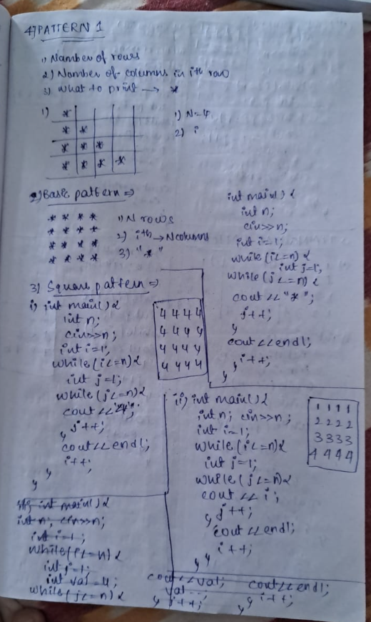

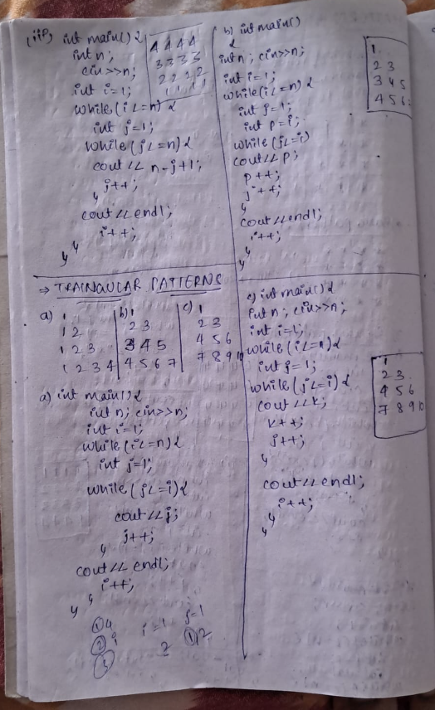

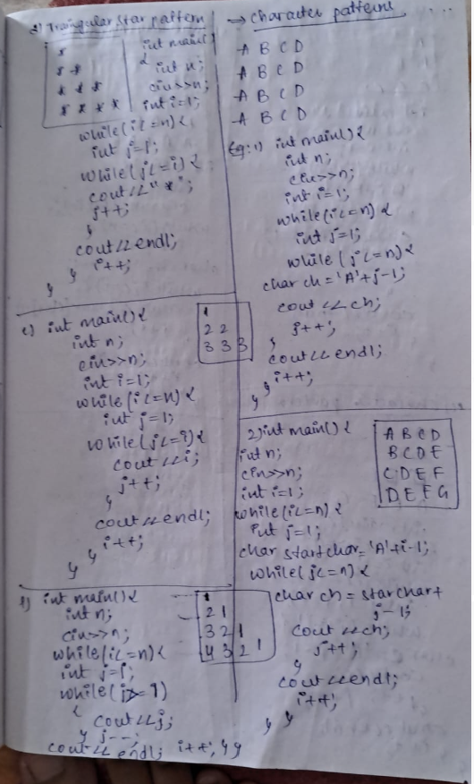

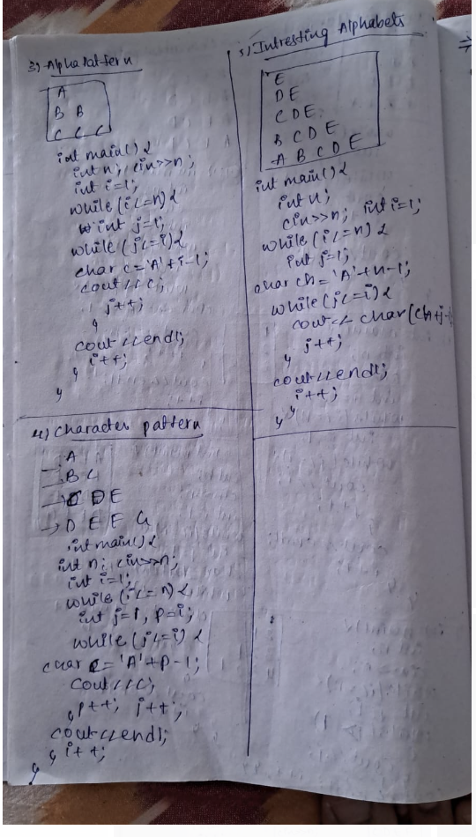

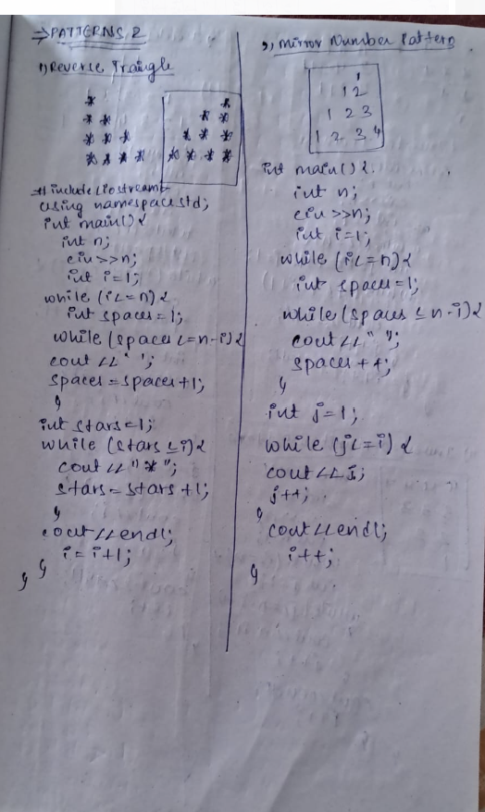

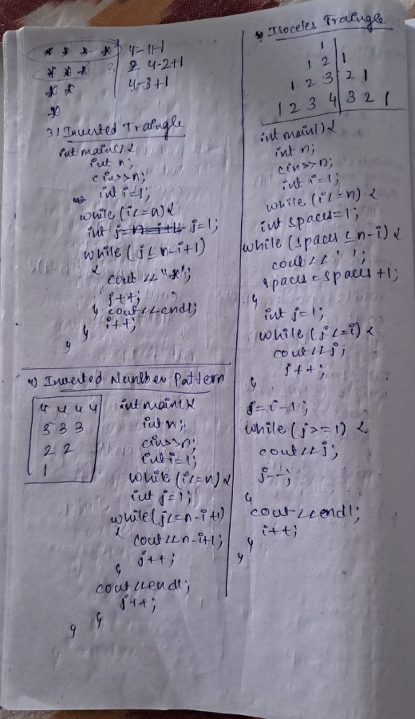

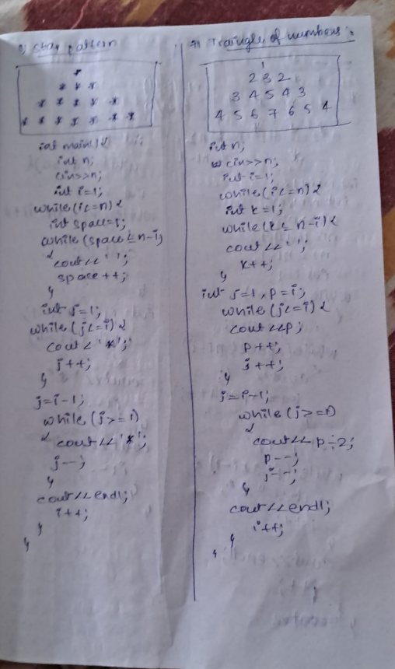

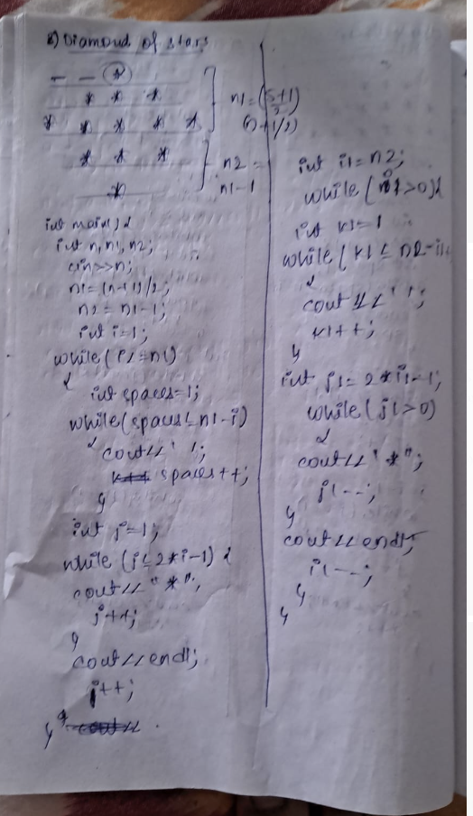

**Code : Square Pattern**

**Print the following pattern for the given N number of rows.**

##### Pattern for N = 4

4444

4444

4444

4444

##### Input format :

Integer N (Total no. of rows)

#include<iostream>

using namespace std;

int main(){

int n;

    cin>>n;

    int i=1;

    while(i<=n)

    {

        int j=1;

        while(j<=n)

        {

            cout<<n;

        j++;

    }

  cout<<endl;

    i++;

}

}

**Code : Triangular Star Pattern**

#### Print the following pattern for the given N number of rows.

##### Pattern for N = 4

*

**

***

****

#include<iostream>

using namespace std;

int main(){

int n;

 cin>>n;

    int i=1;

    while(i<=n)

    {

        int j=1;

        while(j<=i)

        {

            cout<<"*";

            j++;

        }

        cout<<endl;

        i++;

    }

}

**Code : Triangle Number Pattern**

#### Print the following pattern for the given N number of rows.

##### Pattern for N = 4

1

22

333

4444

#include<iostream>

using namespace std;

int main(){

    int n;

    cin>>n;

    int i=1;

    while(i<=n)

    {

        int j=1;

        while(j<=i)

        {

            cout<<i;

            j++;

        }

        cout<<endl;

        i++;

    }

}

**Code : Reverse Number Pattern**

#### Print the following pattern for the given N number of rows.

##### Pattern for N = 4

1

21

321

4321

#include<iostream>

using namespace std;

int main(){

int n;

    cin>>n;

    int i=1;

    while(i<=n)

    {

        int j=i;

        while(j>=1)

        {

            cout<<j;

                j--;

        }

        cout<<endl;

        i++;

    }

}

**Code : Alpha Pattern**

#### Print the following pattern for the given N number of rows.

##### Pattern for N = 3

A

BB

CCC

#include<iostream>

using namespace std;

int main(){

   int n;

    cin>>n;

    int i=1;

    while(i<=n)

    {

        int j=1;

        while(j<=i)

        {

            char c='A'+i-1;

            cout<<c;

            j++;

        }

        cout<<endl;

        i++;

    }

}

#### Print the following pattern for the given N number of rows.

##### Pattern for N = 4

A

BC

CDE

DEFG

##### Input format :

Integer N (Total no. of rows)

#include<iostream>

using namespace std;

int main(){

 int n;

    cin>>n;

    int i=1;

    while(i<=n)

    {

        int j=1,p=i;

        while(j<=i)

        {

            char c='A'+p-1;

            cout<<c;

            p++;

            j++;

        }

        cout<<endl;

        i++;

    }

}

**Code : Interesting Alphabets**

#### Print the following pattern for the given number of rows.

##### Pattern for N = 5

E

DE

CDE

BCDE

ABCDE

##### Input format :

N (Total no. of rows)

#include<iostream>

using namespace std;

int main() {

    int n;

    cin>>n;

    int i=1;

    while(i<=n)

    {

        int j=1;

        char ch = 'A' + n -i;

        while(j<=i)

        {

            cout<< char(ch + j - 1);

            j++;;

        }

        cout<<endl;

        i++;

    }

}

**BITWISE OPERATORS**

#include <iostream>

using namespace std;

int main() {

int ror = 15 | 30;

int rand = 15 & 30;

int rnot = ~15;

int rxor = 15 ^ 30;

int rls = 15 << 2;

int rrs = 15 >> 2;

cout << ror << endl;

cout << rand << endl;

cout << rnot << endl;

cout << rxor << endl;

cout << rls << endl;

cout << rrs << endl;

}

**INCREMENT OR DECREMENT OPERATOR**

#include <iostream>

using namespace std;

int main() {

    int a = 10;

    a += 3;

    a*= 2;

    cout << a-- << endl;

    cout << --a << endl;

}

#include <iostream>

using namespace std;

int main()

{

int x, y = 1;

x = 10;

if (x != 10 && x / 0 == 0)

cout << y;

else

cout << ++y;

}

**A:2**

Even though you get the output as '2', you'll also get a "division by zero" warning. The reason you only get a warning but not an error is short-circuit evaluation. In the if statement, once the first condition (x != 10) is evaluated to be false, then the second condition (x / 0 == 0) is not even executed because the result of the overall condition (x != 10 && x / 0 == 0) will be false. Even if the second condition were true, it would not change the overall result of the two conditions.

However, if the value of x or the first condition itself is changed so that it evaluates to true, then you will get an error because in that case the second condition would also be checked (or executed).

#include <iostream>

using namespace std;

int main()

{

int x = 15;

int y = x++;

int z = ++x;

cout << y << “ “ << z;

}

**A:15 17**

#include <iostream>

using namespace std;

int main()

{

int g = 3;

cout << (++g * 8);

}

**A:32**

#include <iostream>

using namespace std;

int main()

{

int x = 10;

int y = 20;

if(x++ > 10 && ++y > 20 ){

cout << "Inside if ";

} else{

cout << "Inside else ";

}

cout << x << “ “ << y;

}

**A:Inside else 11 20**

#include <iostream>

using namespace std;

int main()

{

int x = 10;

int y = 20;

if(x++ > 10 || ++y > 20 ){

cout << "Inside if ";

} else{

cout << "Inside else ";

}

cout << x << “ “ << y;

}

**A:Inside if 11 21**

#### What will be the output the following code ?

for(int i = 0; i < 5; i = i + 1){

cout << i << " ";

i = i + 1;

}

**A:0 2 4**

#### What will be the output the following code?

for(int i = 1; i < 5; i = i + 1){

cout << i << " ";

i = i - 1;

}

**A:Infinite 1s**

#### What will be the output ?

for(int i = 0; i < 2; i = i + 1) {

for(int j = 0; j < 2; j = j + 1) {

if (j == 1)

break;

cout << j << " ";

}

}

**A:0 0**

#### What will be the output ?

for(int i = 0; i < 5; i = i + 1) {

if(i == 2)

continue;

cout << i << " ";

}

**A:0 1 3 4**

**Nth Fibonacci Number**

#### Nth term of Fibonacci series F(n), where F(n) is a function, is calculated using the following formula -

F(n) = F(n-1) + F(n-2),

Where, F(1) = 1,

F(2) = 1

#### Provided N you have to find out the Nth Fibonacci Number.

##### Input Format :

The first line of each test case contains a real number ‘N’.

##### Output Format :

For each test case, return its equivalent Fibonacci number.

##### Constraints:

1 <= N <= 10000

Where ‘N’ represents the number for which we have to find its equivalent Fibonacci number.

Time Limit: 1 second

##### Sample Input 1:

6

##### Sample Output 1:

8

using namespace std;

int main(){

    int n,i,a=0,b=1,c;

    cin>>n;

    for(i=0;i<n;i++){

        c=a+b;

        a=b;

        b=c;

    }

    cout<<a;

}

**BREAK AND CONTINUE**

#### Which of these jump statements can skip processing remainder of code in its body for a particular iteration ?

**A:Continue**

####"break" is used to exit from the current loop.

####"return" statement is used to exit from the current function.

####"continue" is used to skip the current iteration of a loop and continue with the next iteration.

int i = 1;

while(i < 5) {

if(i == 3) {

break;

}

cout << i << " ";

i++;

}

**A:1 2**

int i = 1;

while(i < 5) {

if(i == 3) {

continue;

}

cout << i << " ";

i++;

}

**A:1 2 Infinite loop**

int i = 1;

while(i < 3) {

int j = 1;

while(j < 5) {

if(j == 3) {

break;

}

cout << j << " ";

j++;

}

i++;

}

**A:1 2 1 2**

int i = 1;

while(i < 3) {

int j = 0;

while(j < 5) {

j++;

if(j == 3) {

continue;

}

cout << j << " ";

}

i++;

}

**A: 1 2 4 5 1 2 4 5**

**All Prime Numbers**

**Send Feedback**

#### Given an integer N, print all the prime numbers that lie in the range 2 to N (both inclusive).

#### Print the prime numbers in different lines.

##### Input Format :

Integer N

##### Output Format :

Prime numbers in different lines

#include <iostream>

using namespace std;

int main(){

int n,i;

    bool a=false;

    cin>>n;

    for(i=2;i<=n;i++)

    {

        a=false;

        int d=2;

        for(;d<i;d++){

            if(i%d==0){

                a=true;

                break;

            }

        }

        if(!a){

            cout<<i<<endl;

        }

    }

}

**SCOPE OF VARIABLES**

#### Will following code generate error ?

#include <iostream>

using namespace std;

int main() {

int a = 10;

if(a > 5) {

int b = 10;

}

cout << b << endl;

}

**A:YES**

#include <iostream>

using namespace std;

int main() {

int a = 10;

if(a > 5) {

int a = 100;

}

cout << a << endl;

}

**A:No**

#### What is the output ?

#include <iostream>

using namespace std;

int main() {

int a = 10;

if(a > 5) {

int a = 100;

}

else {

int a = 110;

}

cout << a << endl;

}

**A:10**

#### Will following code generate error ?

#include <iostream>

using namespace std;

int main() {

for(int i = 0; i < 3; i++) {

cout << i << " ";

}

cout << i << " ";

}

**A: Yes**

#### What is the output ?

#include <iostream>

using namespace std;

int main() {

int a = 10;

while(a > 5) {

int a = 1;

cout << a << " ";

a--;

}

}

**A:Infinite loop**

**Count Characters**

#### Write a program to count and print the total number of characters (lowercase english alphabets only), digits (0 to 9) and white spaces (single space, tab i.e. '\t' and newline i.e. '\n') entered till '$'.

#### That is, input will be a stream of characters and you need to consider all the characters which are entered till '$'.

#### Print count of characters, count of digits and count of white spaces respectively (separated by space).

##### Input Format :

A stream of characters terminated by '$'

##### Output Format :

3 integers i.e. count_of_characters count_of_digits count_of_whitespaces (separated by space)

#include<iostream>

using namespace std;

int main(){

    char c;

     c= cin.get();

    int p=0,n=0,q=0;

    while(c!='$')

    {

        if(c>='a' && c<='z')

        {

            n++;

        }

        else if(c>='0' && c<='9')

        {

            p++;

        }

        else if(c==' ' || c=='\t' || c=='\n')

        {

            q++;

        }

      c= cin.get();

    }

    cout<<n<<" "<<p<<" "<<q;

}

**Sum or Product**

**Send Feedback**

#### Write a program that asks the user for a number N and a choice C. And then give them the possibility to choose between computing the sum and computing the product of all integers in the range 1 to N (both inclusive).

#### If C is equal to -

1, then print the sum

2, then print the product

Any other number, then print '-1' (without the quotes)

##### Input format :

Line 1 : Integer N

Line 2 : Choice C

##### Output Format :

Sum or product according to user's choice

#include<iostream>

using namespace std;

int main() {

    int n,c,i;

    cin>>n;

    cin>>c;

    int sum=0,pro=1;

    for(i=1;i<=n;i++)

    {

        sum=sum+i;

        pro=pro*i;

    }

        if(c==1)

        {

           cout<<sum;

        }

        else if (c==2)

        {

            cout<<pro;

        }

        else

        {

            cout<<"-1";

        }

**Terms of AP**

**Send Feedback**

Write a program to print first x terms of the series 3N + 2 which are not multiples of 4.

#include<iostream>

using namespace std;

int main() {

    int n,i,x;

    cin>>n;

    int count=0;

    for(i=1;count!=n;i++)

    {

         x=3*i+2;

        if(x%4==0)

        {

        continue;

        }

        else

        {

        cout<<x<<" ";

            count++;

        }

    }

}

**Reverse of a number**

**Send Feedback**

#### Write a program to generate the reverse of a given number N. Print the corresponding reverse number.

##### Note : If a number has trailing zeros, then its reverse will not include them. For e.g., reverse of 10400 will be 401 instead of 00401.

#include<iostream>

using namespace std;

int main() {

    int n;

    cin>>n;

    int rev=0,rem;

    while(n!=0)

    {

        rem=n%10;

        rev=rev*10+rem;

        n=n/10;

    }

    cout<<rev;

}

**Binary to decimal**

**Send Feedback**

Given a binary number as an integer N, convert it into decimal and print.

#include<iostream>

using namespace std;

int main() {

    int rem,ans=0,pv=1,n;

    cin>>n;

    while(n>0)

    {

        rem=n%10;

        ans=ans+pv*rem;

        pv=pv*2;

        n=n/10;

    }

    cout<<ans;

}

**Decimal to Binary**

**Send Feedback**

Given a decimal number (integer N), convert it into binary and print.

The binary number should be in the form of an integer.

#include<iostream>

using namespace std;

int main() {

    int n,rem;

    long pv=1;

    long ans=0;

    cin>>n;

    while(n!=0)

    {

        rem=n%2;

        ans=ans+rem*pv;

        pv=pv*10;

        n=n/2;

    }

    cout<<ans;

}

**Square Root (Integral)**

**Send Feedback**

Given a number N, find its square root. You need to find and print only the integral part of square root of N.

For eg. if number given is 18, answer is 4.

#include<iostream>

using namespace std;

int main() {

    int n;

    cin>>n;

    if(n==0||n==1)

    {

        cout<<n;

    }

    else

    {

    int i=1;

    while(i*i<=n)

    {

        i++;

    }

    cout<<i-1;

    }

}

**Check Number sequence**

**Send Feedback**

#### You are given S, a sequence of n integers i.e. S = s1, s2, ..., sn. Compute if it is possible to split S into two parts : s1, s2, ..., si and si+1, si+2, ….., sn (0 <= i <= n) in such a way that the first part is strictly decreasing while the second is strictly increasing one.

##### Note : We say that x is strictly larger than y when x > y.

##### So, a strictly increasing sequence can be 1 4 8. However, 1 4 4 is NOT a strictly increasing sequence.

#### That is, in the sequence if numbers are decreasing, they can start increasing at one point. Thereafter, they cannot decrease at any point further.

##### Sequence made up of only increasing numbers or only decreasing numbers is a valid sequence. So, in both the cases, print true.

##### You just need to print true/false. No need to split the sequence.

##### Input format :

Line 1 : Integer 'n'

Line 2 and Onwards : 'n' integers on 'n' lines(single integer on each line)

##### Output Format :

"true" or "false" (without quotes)

##### Constraints :

1 <= n <= 10^7

##### Sample Input 1 :

5

9

8

4

5

6

##### Sample Output 1 :

true

#include<iostream>

using namespace std;

int main() {

int n;

cin >> n;

int prev;

cin >> prev;

int count = 2, current;

bool isDec = true;

while(count <= n) {

cin >> current;

if(current == prev) {

cout << "false";

return 0;

}

count++;

if(current < prev) {

cout << "false";

return 0;

}

}

else {

if(isDec == true) {

isDec = false;

}

}

prev = current;

}

cout << "true";

}